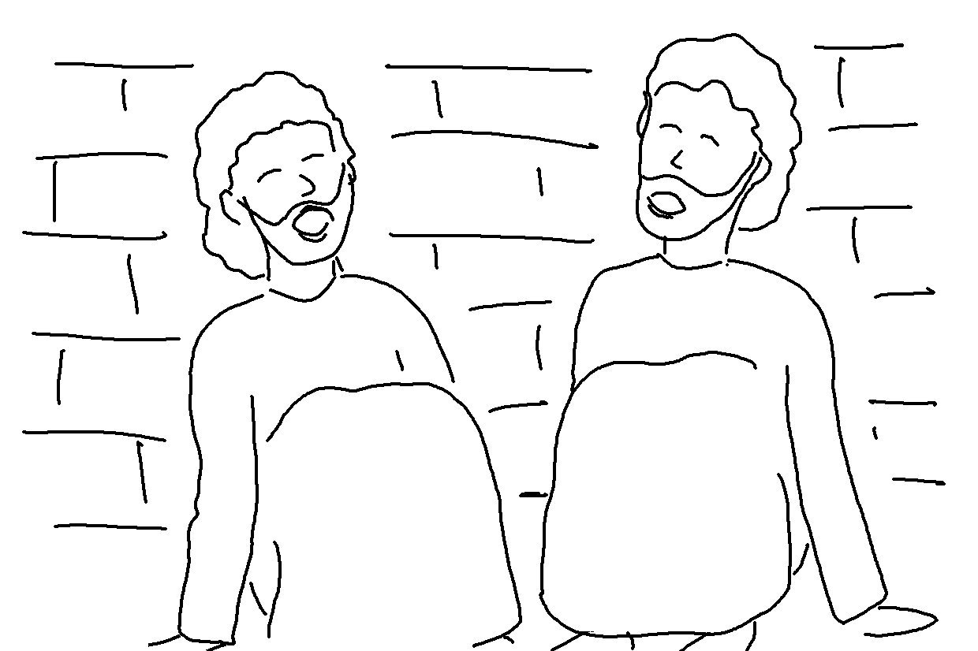
Believe in the Lord Jesus and you will be saved. Acts 16:31_{NLT}

